**VISION:**

*“Establishing highest level of ethical and professional standards in health professionals education, practice and research.”*

**Mission**:

*“To inculcate the basic ethical, professional and humanitarian values in medical students right from the first day of training in order to make them not only expert clinicians but also compassionate human beings.”*

The ’GSMC-MUHS UNESCO Bioethics Unit’ was formed in the month of August 2015. The solemnisation of the Unit under the MCGM Nodal Bioethics Unit and affiliation with UNESCO, Chair in Bioethics Haifa Australia was on 9th November 2015. The MCGM nodal unit was established at an event held in Topiwala National Medical College auditorium.

The objective of Bioethics Unit is to integrate the MUHS approved UNESCO Bioethics curriculum in the undergraduate and postgraduate students education and to train the faculty in effective implementation of the same.

1. To introduce and deliver bioethics and professionalism training in undergraduate and postgraduate curriculum.
2. To prepare an updated and modern curriculum, reflecting the need for integration of ethics during the training period and for its effective implementation in clinical practice.
3. To increase interest and respect to values involved in health care delivery and raising awareness for competing interests. To introduce various non-medical facets of medicine: sociology, economics, and public administration to students.
4. To add new chapters to present curriculum that will relate to new dilemmas, accommodating medical, technological and scientific progress.
5. To create training programs for teachers and instructors of ethics in medical institution.

To initiate, collaborate, facilitate and participate research related to bioethics

The steering committee members are as follows:

|  |  |  |  |  |
| --- | --- | --- | --- | --- |
| **S. No.** | **Name** | **Designation** | **Department** | **Post in Bioethics** |
|  | Dr. Avinash Supe | Dean and Director | MCGM | Chairperson |
|  | Dr Santosh Salagre | Associate Professor | Medicine | Head of Unit |
|  | Dr. Padmaja Marathe | Additional Professor | Pharmacology | Head, Steering Committee |
|  | Dr Nayana Ingole | Associate Professor | Microbiology | Secretary |
|  | Dr. Mariya Jiandani | Associate Professor | Physiotherapy | Treasurer |
|  | Dr. Padmaja Mavani | Additional Professor | Obstetrics and Gynaecology | Member |
|  | Dr Yuvaraj Chavan | Associate Professor | Community Medicine | Member |
|  | Dr. Kanchan Kothari | Associate Professor | Pathology | Member |
|  | Dr Anjali Telang | Assistant Professor | Anatomy | Member |
|  | Dr. Monty Khajanchi | Assistant Professor | General Surgery | Member |
|  | Dr Kinjalka Ghosh | Assistant Professor | Biochemistry | Member |
|  | Dr. Venkatesh Rathod | Assistant Professor | Physiology | Member |
|  | Dr Karuna Nadkarni | Associate Professor | Occupational Therapy | Member |
|  | Mrs. Pradnya Nachankar | Sister Tutor | School of Nursing | Member |

Nominations were invited for formation of student’s wing and the members were selected from undergraduate students after interview. The members of the student’s wing are as follows:

|  |  |  |
| --- | --- | --- |
| SR NO | NAME | YEAR |
| 1 | AARSI POPAT | INTERN BPTH |
| 2 | AMEYA KAKODKAR | BPTH IV |
| 3 | ASHWINI JADHAV | II YEAR GNM |
| 4 | ASMITA WANKHEDE | I YEAR GNM |
| 5 | DEVI BAVISHI | MBBS III/I |
| 6 | EKTA PATIL | INTERN BPTH |
| 7 | GAUTAMI CHAUDHARI | MBBS III/I |
| 8 | HEMA JOSHI | INTERN RGNM |
| 9 | HIMANI GIROLKAR | BPTH II |
| 10 | JAYASHRI PAWAR | III YEAR RGNM |
| 11 | OMKAR THAKUR | BPTH III |
| 12 | PUJA BHUJBAL | I YEAR GNM |
| 13 | POOJA ZIPRE | III YEAR RGNM |
| 14 | PRAJAKTA KULKARNI | INTERN BOTH |
| 15 | PRATIK DEBAJE | MBBS II/I |
| 16 | RESHMA MESTRI | INTERN RGNM |
| 17 | SANJEEVANEE CHARDE | BOTH III |
| 18 | SARAH SAROSH | BOTH II |
| 19 | SAYLI KALZUNKAR | BOTH IV |
| 20 | SIDDHI PATANGE | II YEAR GNM |
| 21 | VAISHNAVI MASKE | MBBS III/I |

World Bioethics Day 2016

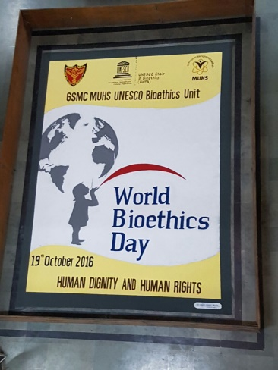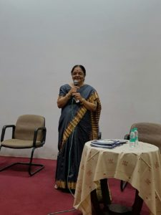

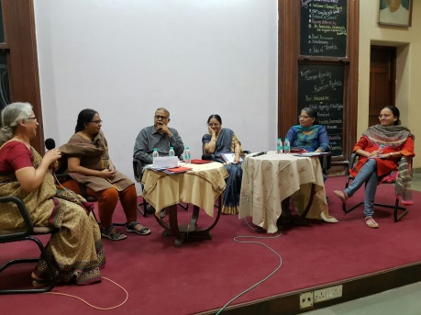

The first world Bioethics day with the theme “Human Dignity and Human Rights” was celebrated by organizing various activities like Ebate – the ethics debate, Poster competition, interactive games, skit, panel discussion, release of the first annual bulletin of the unit “Inarch” and key note address by Dr. Snehalata Deshmukh, Pediatric Surgeon, Former Vice Chancellor, University of Mumbai.

Teaching module for students of second MBBS, Occupational Therapy, Physiotherapy on 8th December 2016

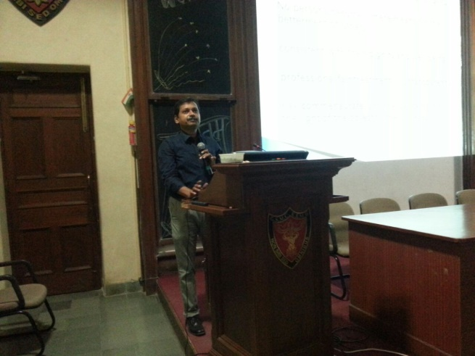

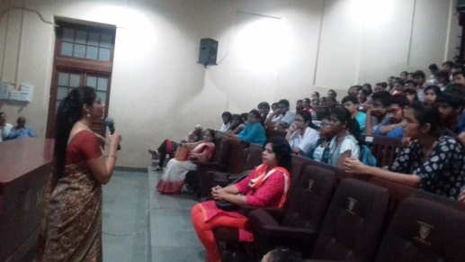

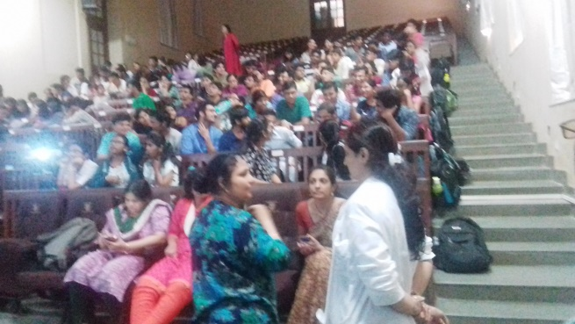

Teaching module was conducted on 8th December 2016 for students of second MBBS, Occupational Therapy, Physiotherapy. Approximately 150 students attended the lecture series. Topics such as Empathy, benefits and harm, Research ethics and principles of research were covered using various teaching learning methods. Various videos were shown and different real life cases were discussed to drive home various ethical issues.

Teaching module for students of first MBBS, Occupational Therapy, Physiotherapy on 13th December 2016





Report of the Module 1 of Bioethics curriculum for first year MBBS, Occupational Therapy and Physiotherapy students was conducted on 13th December 2016. Approximately 145 students attended the lecture series. The workshop began with address by Dr.Avinash Supe, Director (ME & MH)and Head of GSMC MUHS-UNESCO Bioethics Unit. He emphasized the need of understanding principles of Bioethics through a solid curriculum right from the first year of medical course to enable students to play a vital role in health research and decision making in health related issues. Interactive sessions on Introduction to Principles of Bioethics, History of Bioethics, Human Dignity & Human Rights and Cultural Diversities were conducted using video clips and case discussions.

Teaching module for students of first MBBS, Occupational Therapy, Physiotherapy on 3rd February 2017

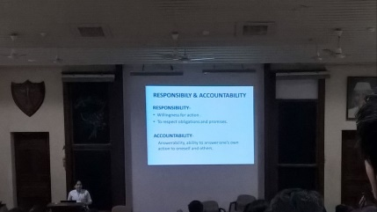

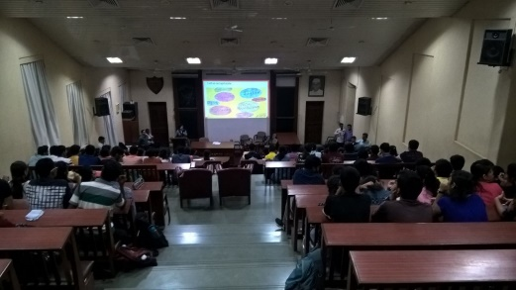

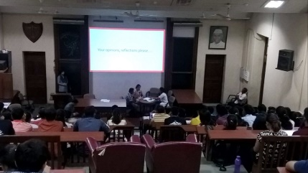

A session for first year MBBS students based on Module 2 of UNESO Bioethics curriculum was organized on 3rd February 2017. The session that included 5 lectures was attended by approximately 150 students. The special features of this session were the introduction of pre-session assessment, post-session assessment and feedback from the students. Topics such as autonomy, consent, responsibility, equality and justice and non-stigmatization and non-discrimination were covered using various interactive teaching learning methods including role play.

Orientation Session on Bioethics” for Interns of November 2016 batch on 3rd March 2017

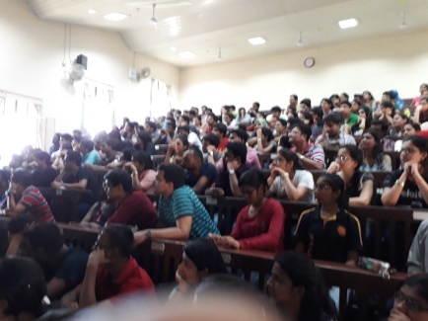

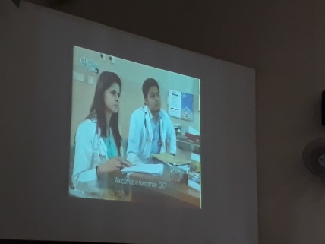

The “Orientation Session on Bioethics” for the interns (November 2016 batch) was organized on 3rd March 2017 and was attended by approximately 175 interns.

The whole session focused on frequent situations the interns are likely to face in clinical wards. The problem of **consent in vulnerable population** was illustrated with the help of role play. Professionalism, privacy of patient, cultural and social issues, autonomy, consent, etiquettes of a health care professional, patient respect and dignity was depicted using video clips. The bioethical principles of autonomy, beneficence, non-maleficence, justice and confidentiality were explained using **power point presentation with illustrations.** **A role play on autonomy** was also performed highlighting the doctor’s role in helping the patient to make an informed decision. The session ended with “***A page from Diary of Mrs. Desai*”:** An elderly single lady refusing chemotherapy for breast cancer in view of poor quality of life that is likely to follow after chemotherapy.

**International Course in Bioethics for Medical, Dental and Health Science Teaching Faculty of MCGM Medical / Dental Colleges 27th February to 1st March 2017**

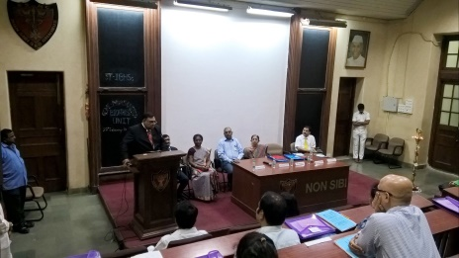

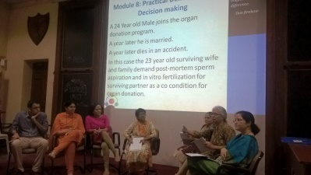

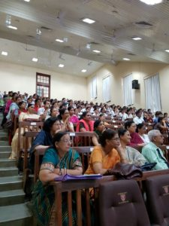

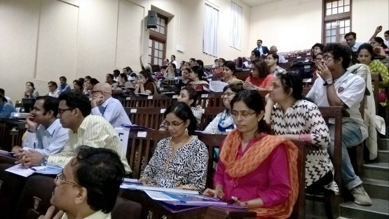

The accredited 3T-IBHSc bioethics training program has been designed to introduce Medical, Dental and Health Science teaching faculty of Universities and Colleges to teaching the modern Vertically Integrated Bioethics Curriculum based on the core curriculum, which reflects the 15 principals enshrined in the UNESCO’s Universal declaration on Bioethics and Human Rights (2005). 3T – IBHSc workshop was organized by GSMC MUHS UNESCO Bioethics Unit, Seth G S Medical College & KEM Hospital, Mumbai for Steering Committee members of Bioethics Units of MCGM run medical and dental colleges from 27th February to 1st March 2017. 63 faculty members participated and 60 completed the training.

Faculty members who participated were teachers from various colleges across the country. Dr Russell D’Souza Head & Chair Asia Pacific Division UNESCO Chair in Bioethics Haifa led the team consisting of Dr S Mini Jacob, Dr Avinash Desousa, Dr Santosh Salagre, Dr Padmaja Marathe, Dr Shaguphta T Shaikh , Dr PinakiWani,Dr Anjali Telang, Dr AnuradhaKanhere, Dr Mangesh Lone, Dr ShivaniBansal. The course used the methodology of a group of ‘Co-Learners’ where training faculty and participant teaching faculty are co-learners, using the process of ‘Learning through osmosis.” The 3 day course had 3 components:

Part A: Bioethics Principles

Part B: Bioethics Knowledge Transfer Technology

Part C: Integrated Bioethics

**Activities of the student’s wing**

1. **Essay competition**

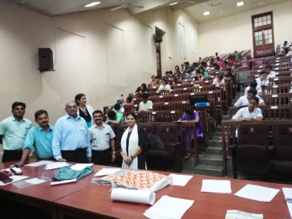

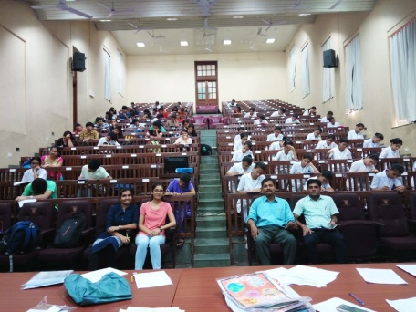

An essay competition was organized to celebrated the World Bioethics Day 2017 for MBBS, OT, PT, Nursing, PG students AND all faculty of GSMC on Tuesday, 3rd October 2017.

**Topics for the essay**

1. Gender equality. ‘Stree purush samaanataa’
2. Equity for disabilities– in health care. ‘Arogya sevaomein Divyangonke liye samabhaav’
3. Distributive justice and health care for all. ‘Vitaranatmak nyay aur arogya seva’.
4. Environmental justice. ‘Paryavaranatmak nyay’.

A total of XXX faculty and students participated in the competition.

1. Poster Competition

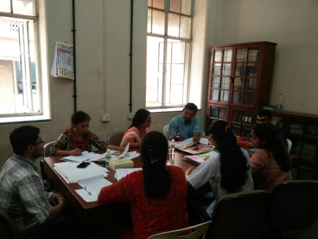

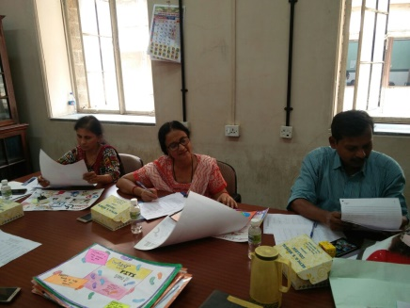

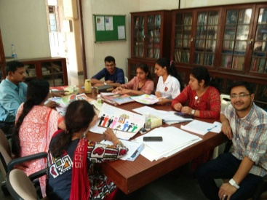

Blending with the theme of World Bioethics Day 2017 – “Equality, Justice and Equity”, the GSMC MUHS UNESCO Bioethics unit held a poster competition for all Undergraduates (MBBS, PT, OT and NURSING), Interns, Postgraduates (all disciplines), Faculty & Seth GSMC and KEMH employees. A total of 59 participants submitted the posters which were judged by Dr. kamaxi Bhate, Dr. Y. B. Chavan and Mrs. Swati Bhide.

1. Other activities

Blending with the theme of World Bioethics Day 2017 – “Equality, Justice and Equity”, the GSMC MUHS UNESCO Bioethics unit also organized a Short film making and skit competition for students of MCGM medical colleges. Ebate – the ethics debate was also conducted for all undergraduate students of Seth GSMC & KEMH.